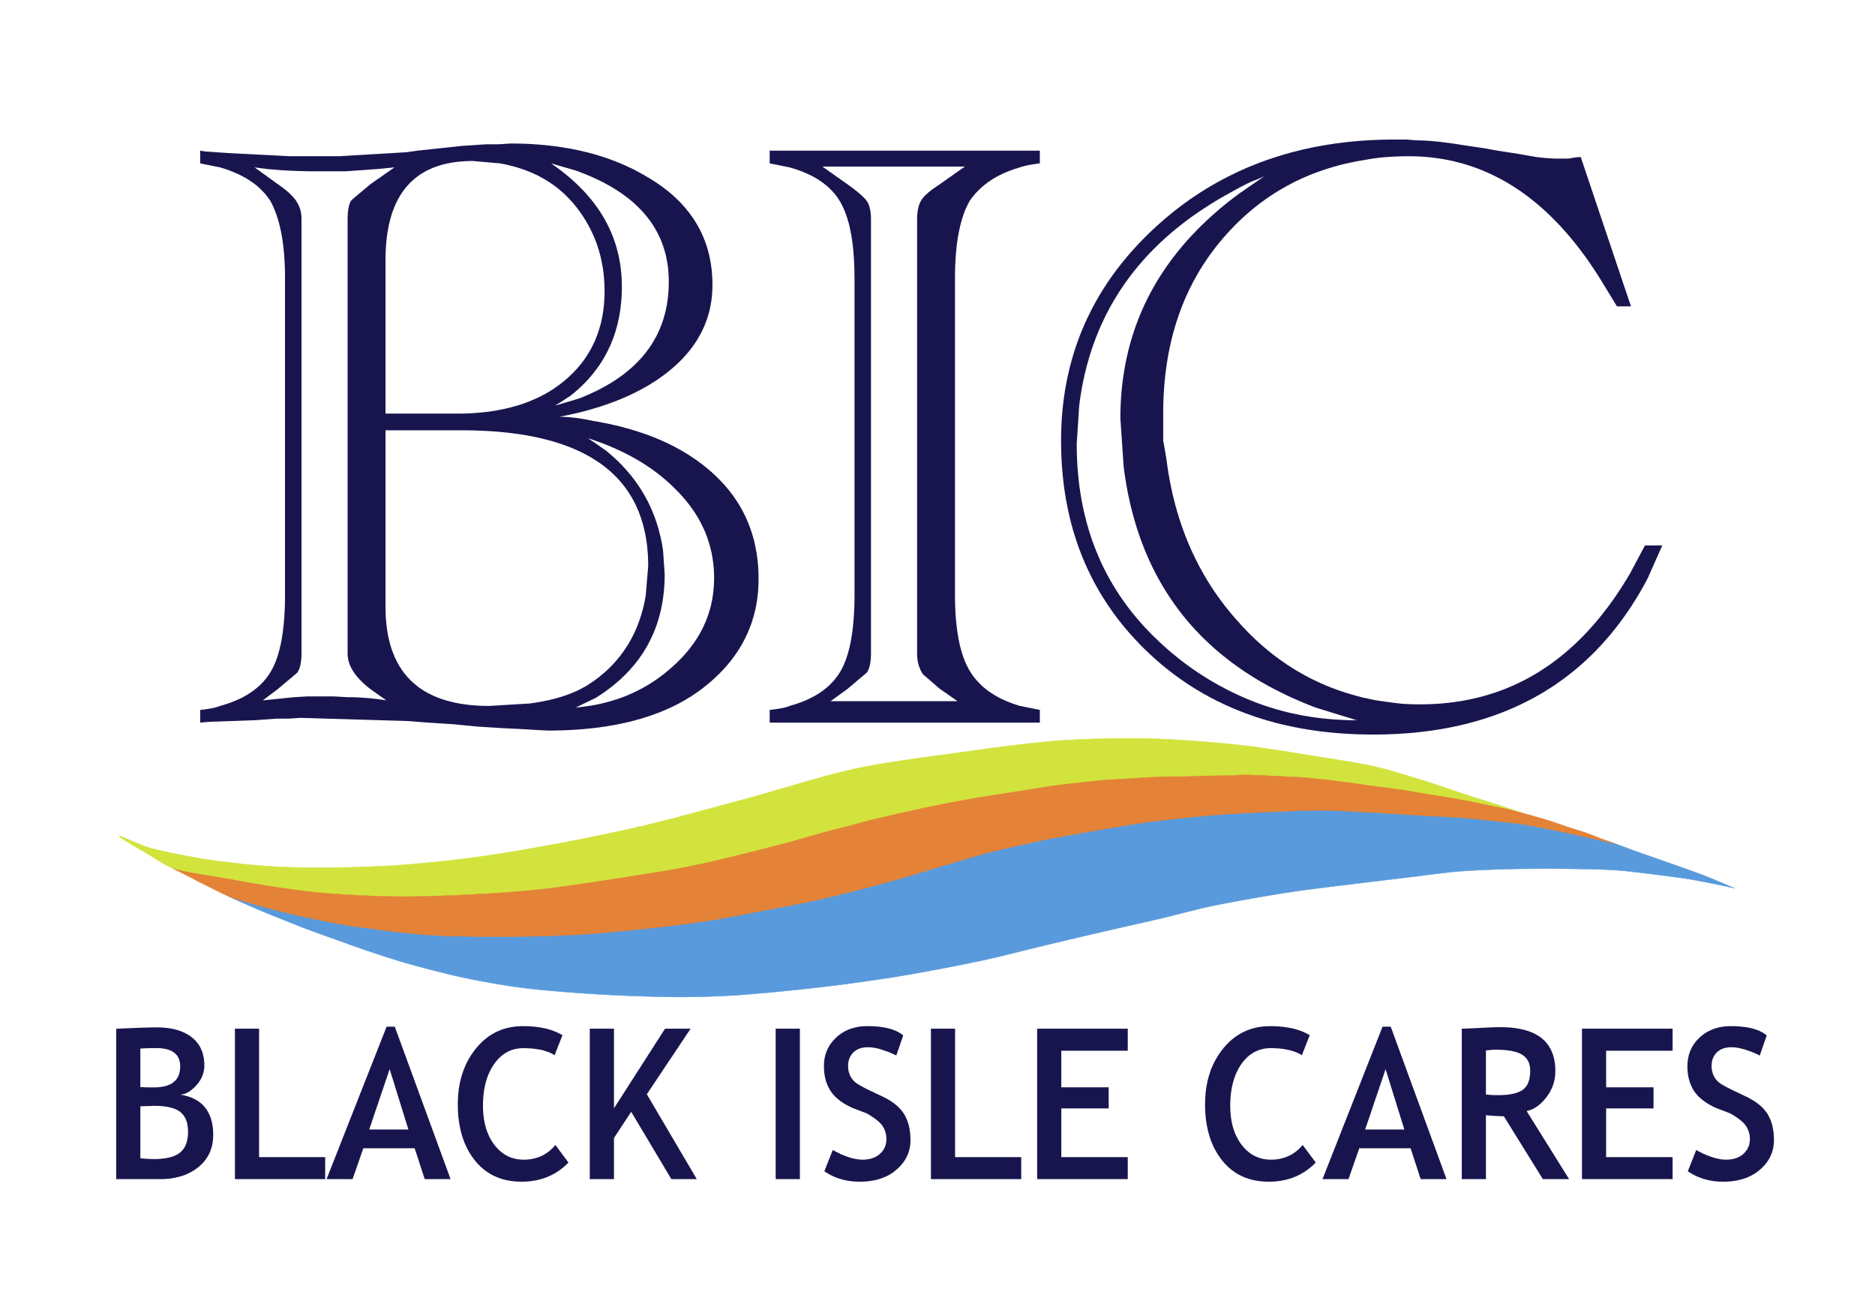
Charity Number : SCO 45371

Minutes of the Annual General Meeting of Black Isle Chares held on Monday, 27th March 2023

PRESENT
Trustees : Anne McDonald (Chairperson), Wilma Halley, Jenye Monckton, Freida McKenzie, Margaret Rhynas
Volunteers : Rod McKenzie, Mike Halley, John Tuach, Niamh Kelly, Ella Patience, Gillian Bartrop-Young, Bridget Houston, Rebecca Stewart
Others: Megan Mackenzie, Fraser ThomsonCouncillor Sarah Atkin, Tom Leslie, Lynda Smith
Guest Speakers: Harry Tedstone, Isobel Grigor and Jackie Ross
1. Welcome
Anne McDonald welcomed everyone to the Annual General Meeting and thanked them for attending.
2. Apologies
Apologies were received from the following:
Trustees : Simon Hamilton-Cole (Treasurer), Isla Mackay and Ian Macnamara
Volunteers: Alistair Fern, Paul Wadge, Fran Crowhurst, Andy Minett, Val Skelton, Elaine Murray, Heulwen Blackmore, Fiona Macdonald & Gillian Kerr
Others: Brian Devlin, Betty Prentice, Ian Goode, Cathryn Macpherson, Graham & Genevieve Maciver, Joanie Whiteford and Wanda Mackay
3. Approval of the Minutes of the previous Annual General Meeting dated 27th October 2021
Approval proposed by Freida McKenzie and seconded by Margaret Rhynas.
4. Report by Chairperson
Anne McDonald confirmed that her report was for the year 2021. She advised that 2021 had been a very busy year for Black Isle Cares and presented a slide show of photographs of events that had taken place during the year. As a result of Covid restrictions, all meetings during the year had been held online and newsletters had been produced to keep all interested parties informed.
Anne presented a summary of activities that had taken place during the year, which included the following:
The production of new leaflets.
The setting up of the Community Larder, including a pet food section. All elements of the larder were and continue to be very well used.
Volunteers were involved in making Covid masks.
2989 meals were delivered during 2021 to 30 ladies and gentlemen by 40+ volunteers. These meals were produced by a variety of restaurants, which included the White Cottage and Allangrange.
The clients also received gifts on Valentines Day, Daffodils at Easter and hampers on St Andrew’s Day. Students from Fortrose Academy helped with the deliveries of these items.
In March 2021, the Befriending Service was set up with, initially, 4 clients and 4 volunteers.
A survey was carried out which identified gaps.
The Community Garden was maintained and used as a meeting place for both individuals and groups.
The Annual General Meeting was held in October 2021 using Zoom.
A St Andrew’s day afternoon tea was held for clients.

Anne continued to summarise the events that had taken place during 2022 :
During 2022 a partnership was established for the provision of food by the Highland Farm Café in Dingwall and Shopmobility. Meals were also provided by Calman Trust which broadened the intergeneration work of Black Isle Cares.
Children from Avoch Primary School interviewed senior citizens of the Black Isle – this was known as Stories from the Black Isle. A film of this has recently been produced, which was premiered for the students during May 2023.
Intergenerational Games Afternoons commenced at Fortrose Academy Library and garden art boards were painted by students from Fortrose Academy (these are currently being repaired).
The Queen’s Award was received in December 2022 and a Christmas Lunch was provided for ladies and gentlemen of the Black Isle.
Anne McDonald finished her report by thanking all the volunteers, trustees, students and members of the local community who have and continue to support Black Isle Cares. She advised that a group to be known as ‘Friends of Black Isle Cares’ is being established and asked anyone interested to sign up to become a member (forms were available at the meeting).
5. Treasurer’s Report & approval of Annual Accounts for the year ending 31.01.2022.
Simon Cole-Hamilton, Treasurer was unable to attend the meeting, but had provided the attached accounts for the year and Lynda Smith read the following report from him:
I am sorry not to be able to attend in person, but here is my report. Please bear in mind that the figures under review cover the year which ended 31 January 2022 – which is now more than a year ago.
The accounts show a deficit for the year of £7,110 leaving bank funds at the year end of £46,469. The deficit is mainly related to our restricted funds, and more specifically our Meals on Wheels project. This project is basically self-funding in terms of the meals themselves, and the deficit arises from admin costs and the provision of free meals for trial periods. Never the less the project still had funds in excess of £20,000 at the year end – more than adequate to maintain the project for several years
Grants were received for Befriending – from the Black Isle Partnership - and for Anniversary Teas for our clients from Age Scotland’s resilience fund . The befriending project is ongoing and demand for it’s services is growing steadily. We are very grateful to both organisations for their support, and to the many other smaller benefactors who gave donations to us during the year, including Caley Timber, the Co-op, Killearnan Church, and many others. Grants and Donations are essential if we are to continue our activities and to maintain an office with a project co-ordinator.
Our major costs remain the purchase of meals, salary for our project co-ordinator, and office and admin expenses. Not shown in the figures is the major contribution made by our volunteers and Trustees who give their time so freely and willingly and without whom we could not deliver our services. We are very grateful for their continued support and their belief in the benefits to society in the work we undertake.
The accounts have been examined by our Independent Examiner, Ricky Finlayson CA of Mackay & Co, Dingwall, and have been submitted to, and accepted by, the charity Regulator OSCR.
In closing therefore I would say that the project ended the year with adequate funds for its continued operation (and indeed we have operated satisfactorily for 13 months since the year end) and is well placed to continue providing services to our Black Isle community.

The Report and Accounts were approved by Margaret Rhynas and seconded by Jenye Monckton.
6. Appointment of Independent Examiner
Wilma Halley proposed that Mackay & Co be reappointed as the independent examiner for the 2022/2023 financial year and this was seconded by Freida McKenzie.
7. Election of Trustees to the Board
Anne McDonald advised that Isla Mackay had decided to step down from her role as Secretary and resign as a Trustee. Thanks were expressed to Isla for her work and support over the years.
The following Trustees had declared a willingness to stand again as Trustees:
Anne McDonald, Freida McKenzie, Wilma Halley, Simon Cole-Hamilton, Jenye Monckton, Margaret Rhynas and Ian Macnamara.
Rod McKenzie proposed that the above should be reappointed as Trustees and this was seconded by Mike Halley.
Anne Mcdonald reported that new Trustee members would be very welcome.
8. Guest Speaker – Harry Tedstone, Highland Hospice
Harry Tedstone described the role of the Highland Hospice. Part of the work carried out is the provision of palliative care and to ensure the patients are made as comfortable as possible in the short time remaining to them. He explained that the Hospice has a wider community role and has established partnerships with organisations, such as Black Isle Cares, to meet social requirements of members of the Highland and Island communities. The services provided by Black Isle Cares meals at home delivery, befriending and intergenerational games all form part of these social needs.
The Befriending Service was initially provided by the Hospice, but it was found that this could be better provided by local organisations who could adapt according to local need. He explained how the services offered differ depending on local requirements and gave examples of different types of provision.
Harry advised that 80% of the support provided by the Hospice is in the community and 20% is end of life care.
Harry was thanked for attending the meeting.
9. Guest Speaker – Isobel Grigor, Calman Trust
Isobel explained that the Calman Trust has been in existence for 25 years. She described how the Trust works with young people who have had a difficult start in life for a variety of reasons. The Trust runs the Artysans Café in Inverness which provides work and training for the young people. The life experience gained is invaluable in building confidence and enabling the youngsters to move on to other opportunities.
For approximately one year, the Calman Trust made and delivered meals one day a week to senior citizens in the Culbokie, Kessock and Hilton areas of Inverness. The meals were delivered by two young volunteers. This service was very successful and both the young volunteers and the senior citizens enjoyed the intergenerational contact. Unfortunately, this service had to stop due to cost implications, but it is hoped that it could be re-established in the future.
10. Guest Speaker – Jackie Ross, Headteacher Fortrose Academy
Jackie explained that there is a partnership between Fortrose Academy and Black Isle Cares to provide intergenerational activities between students and senior citizens of the local community.
Margaret Rhynas, Wanda Mackay and Fraser Thomson support the students in the organisation of activities. Following on from Covid, Jackie advised that the impact on the wellbeing of the students is immense and also enables the development of collaborative, creative and organisational skills. The activities encourage the development of relationships with the senior citizens, staff of the local Care Home and Trustees of Black Isle Cares.
In summary, Jackie confirmed that there are benefits for all involved as a result of this partnership and thanked Black Isle Cares for allowing the school and students to be part of the intergenerational project.
11. Premier of Stories from the Black Isle – a short film about Avoch Primary School and the Black Isle Storytelling Project
Anne McDonald explained how students from Primary 6 in Avoch had written letters and invited local senior citizens into school to be interviewed about their life experiences. The pupils were provided with training on interviewing and note taking skills. Tom Leslie had produced a short film featuring the stories gathered by the pupils and this was shown at the meeting.
12. Any Other Business
Mike Halley reported that a Playlist of Life will be starting on 1st May 2023 in Fortrose Library. This involves putting together catalogues of music from certain eras which is used to help people diagnosed with dementia.

The meeting closed at 8.15 pm.

